**SWE230-Team Project Phase 1 Evaluation**

|  |  |  |  |
| --- | --- | --- | --- |
| **Project** **Title**: | | | **Team Code** : |
| **Items** | **Weight** | **Grade** | **Notes** |
| Frontend pages covering all application requirements | 20 |  |  |
| Client side validation on all forms using JavaScript | 20 |  |
| Application UI/UX quality | 5 |  |
| Folder Structure | 5 |  |
| External CSS files | 10 |  |
| External JavaScript files | 10 |  |
| Innovation | 10 |  |
| **Project Total Grade** | **80** |  |

# **Team Individual Evaluation and Final Grade**

|  |  |  |  |  |  |
| --- | --- | --- | --- | --- | --- |
|  | **ID** | **Group**  **(01/02/ 03/04)** | **Name as in MIU ID** [Sorted in ascending order] | **GitHub Commits**  **(20)** | **Total (100)** |
| **1** | 2022/04058 | 01 | Adham Mohamed Abdel-Aziz Mahmoud |  |  |
| **2** | 2022/07878 | 05 | Mohamed Gamal Mohamed |  |  |
| **3** |  |  |  |  |  |
| **4** | 2022/01534 | 05 | Yassin Ehab Mamdouh |  |  |
| **5** | 2022/06547 | 04 | Ziad Mohamed Awad |  |  |

Assessor Name : Assessor Signature :

# **Project Information**

**Live Application URL : https://adham-mohamed-lo.github.io/Web-Fit-Project/**

# Abstract Web-Fit" is your go-to online fitness destination, designed to help you smash your wellness goals. Dive into our collection of easy-to-follow workouts and exercises, customized to fit your needs and preferences. Whether you're aiming to slim down, bulk up, or boost stamina, we've got you covered. Join a supportive community, track your progress, and stay motivated every step of the way. Embrace a healthier, happier you with Web-Fit!

# GitHub repository

**GitHub URL:** [**https://github.com/Adham-Mohamed-lo/Web-Fit-Project.git**](https://github.com/Adham-Mohamed-lo/Web-Fit-Project.git)

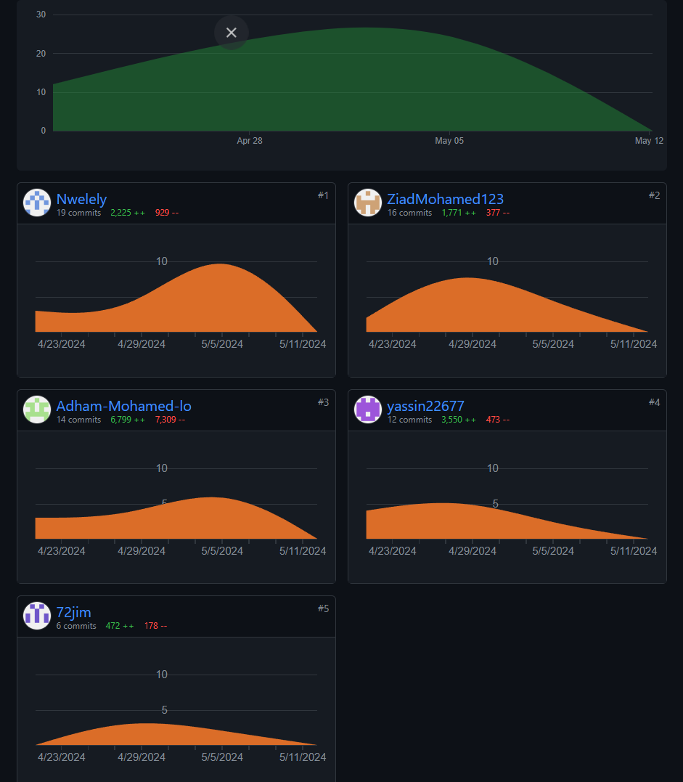

Include screenshots of your project GitHub repository and contributors’ insights showing each team member commits.

# Tasks distribution:

|  |  |  |  |  |  |
| --- | --- | --- | --- | --- | --- |
| ID | Task name | Description | Start date | Duration in hours | Assigned to |
| 1 | Contact Page | Contact Page contain call us and mail to make the connection easy | 25-4 | 4 hours | Ziad Mohamed |
| 2 | Contact Form | Allow the user to send us messages with validation | 26-4 | 3 hours | Ziad Mohamed |
| 3 | Services Card | Making Cards for (Coaches-Membership-Shop) | 28-4 | 2 hours | Ziad Mohamed |
| 4 | Online Payment | Online visa card for paying with validation | 30-4 | 6 hours | Ziad Mohamed |
| 5 | Admin Page | Html and JS of the Admin page (Add-remove-edit-view) HTML | 3-5 | 10 hours | Ziad Mohamed |
| 6 | About | Creating the html with layout of the page | 26-4 | 3 hours | Yassin Ehab |
| 7 | Free plan | Contains the workout card that is available for non-subscribers HTML and JS | 28-4 | 2 hours | Yassin Ehab |
| 8 | Standard plan | Contains two cards the first one contains the workout and the other contains the meals HTML and JS | 28-4 | 3 hours | Yassin Ehab |
| 9 | Premium plan | Contains two cards the first one contains the workout and the contains the meals also it contains the ability of the user to choose his coach HTML and JS | 30-4 | 6 hours | Yassin Ehab |
| 10 | Coaches card | It contains the coach’s pictures and ability to see his schedule HTML and JS | 2-5 | 3 hours | Yassin Ehab |
| 11 | Workout card | It contains 3 other cards which are (push, pull, legs)  Each card contains number of workouts with gifs to make it easier for the user to understand the workout HTML and JS | 4-5 | 7 hours | Yassin Ehab |
| 12 | Meal’s card | It contains 3 meals each meal contains the ingredients of it HTML and JS | 5-5 | 2 hours | Yassin Ehab |
| 13 | Shop Page | It allows users to browse products, add them to the cart, view the cart, remove items, and checkout. Key features include dynamic product display, cart management | 28-4 | 8 hours | Adham Mohamed |
| 14 | Cart form | Cart for adding shop items in it revise it (+,-,delete) and to checkout | 28-4 | 1 hours | Adham Mohamed |
| 15 | Style and files optimizing over all | Unify the project styles and optimizing files | 6-5 | 20 hours | Adham Mohamed |
| 16 | Nav and login js with file and folder handling | It updates the link text and URL dynamically, including logout functionality using session storage for user or admin data to access (user,admin) profile | 6-5 | 4 hours | Adham Mohamed |
| 17 | Home page | It contains the background picture and 3 icons at the bottom | 22-4 | 2 hours | Mohamed gamal |
| 18 | About page | Information about the website and our team with pictures included | 6-5 | 3 hours | Mohamed gamal |
| 19 | Login page | Layout of the login and signup page and validation and javascript | 29-4 | 3.5 hours | Mohamed gamal |
| 20 | Join us page | Layout of the join us page and validation | 27-4 | 2.5 hours | Mohamed gamal |
| 21 | Home page | It contains the background picture and 3 icons at the bottom | 22-4 | 2 hours | Mohamed gamal |
| 22 | Shop page | Added items with pictures to our shop | 7-5 | 1.5 hours | Mohamed gamal |
| 23 |  |  |  |  |  |
| 24 |  |  |  |  |  |
| 25 |  |  |  |  |  |
| 26 |  |  |  |  |  |
| 27 |  |  |  |  |  |
| 28 |  |  |  |  |  |
| 29 |  |  |  |  |  |
| 30 |  |  |  |  |  |